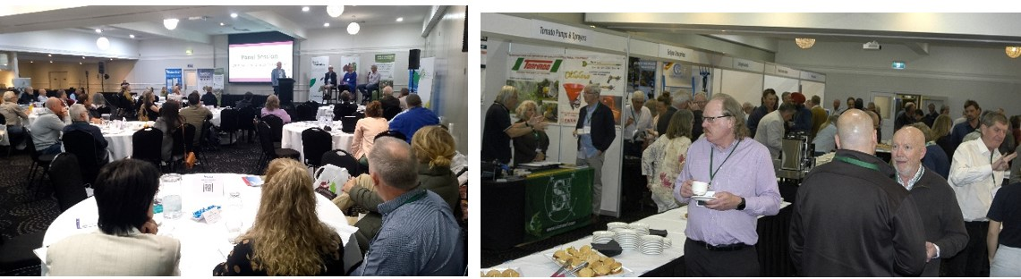 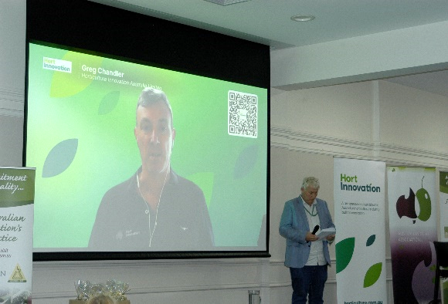 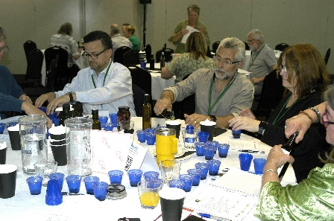

**2025 National Olive Conference program suggestions welcomed**

The annual National Conference is *your* event and the AOA’s organising team are keen to ensure that the program and other activities meet the needs, wants and interests of all attendees.

Planning is already well underway for the 2025 Conference, with the location and venue to be confirmed very soon. Which leaves the other big to-do item: the program. Feedback from 2024 event delegates has been taken on-board and the organisers are keen to also hear from a wider industry audience.

So if there’s a topic you’d like to know more about, an issue you really need dealt with, and/or a relevant speaker you’d like to hear from, please let the AOA know so they can add it to the discussion mix.

The same goes for workshops, field tours, etc: your input is very welcome, and will help ensure the 2025 National Olive Conference & Exhibition is the event *you* want to attend!

Please send your suggestions to AOA Administration Manager Liz Bouzoudis at [*secretariat@australianolives.com.au*](mailto:secretariat@australianolives.com.au)*.*

*The National Olive Conference & Trade Exhibition is facilitated by the Australian Olive Association, partially funded by Hort Innovation using the Olive R&D levy, with in-kind contributions from the Australian Olive Association and funding from the Australian Government. The event is also supported by a range of industry sponsors and exhibitors.*